Open Industry 4.0 Alliance and Labs Network Industrie 4.0 work together for digital transformation
The two industry associations are cooperating closely, especially on testing implementations
Reinach, Schweiz, 22.11.2022 – The Open Industry 4.0 Alliance is now working together with the Labs Network Industrie (LNI) 4.0 e.V. - a fast growing network of more than 45 renowned test centers (labs) and around 300 companies throughout Germany. The LNI 4.0 test the most diverse industry 4.0 topics in their practical application across more than 120 use cases and five large testbeds. As part of their partnership, the Open Industry 4.0 Alliance and the LNI 4.0 are leveraging their collaborative synergies to test implementations of Industry 4.0 use cases for medium-sized businesses.
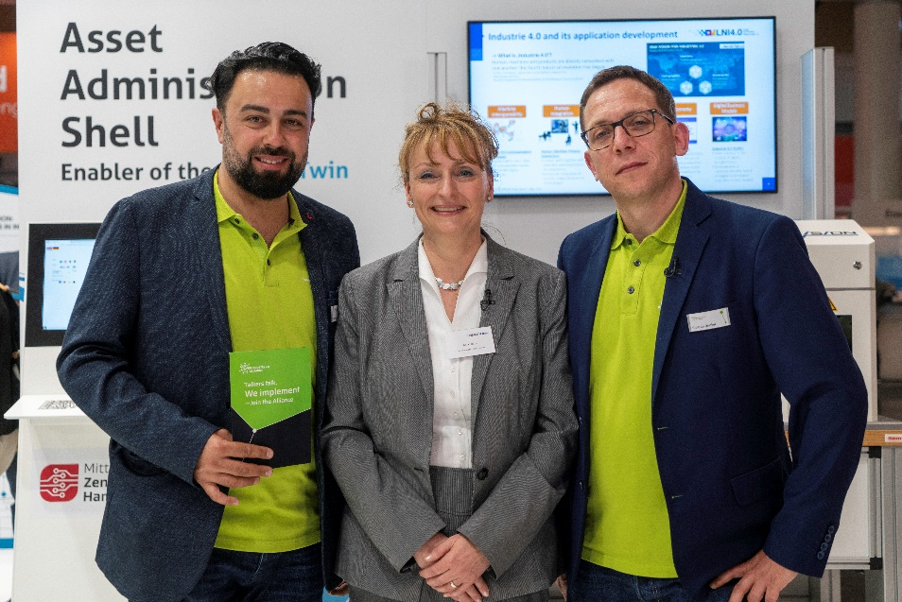
The collaboration between the two associations is expected to lead to significant scaling in the implementation of industrial transformation across Germany and Europe. The LNI 4.0 brings its numerous test labs and its five large test beds to the table. The existing overlap in members - major players in the manufacturing, electronics and software industries in Germany that participate in both organizations - is a great advantage for the scaling of transformation projects.
“Standards alone won`t make implementation happen,” explains Ricardo Dunkel, Technical Director of the Open Industry 4.0 Alliance. “That's why we expect cooperation with the LNI 4.0 and the use of its test beds for our joint members to lead to the best possible implementation results for our members' end customers.”
“We expect that our joint work on use cases will increase the potentiation of digital transformation implementation for our members by a factor of five to ten,” says Anja Simon, CEO of LNI4.0. “We can test many different Industry 4.0 application scenarios and do so in a neutral and pre-competitive way for both communities.”
The two organizations intend to focus their collaboration on three key areas:
- Edge Management: small and medium-sized enterprises can test the range of different edge solutions via a neutral exchange and testing platform.
- Digital Twin: providing the technical basis and application scenarios for the digital twin, based on the Asset Administration Shell (AAS).
- Data Spaces: this includes collaboration to meet the stipulations of the EU Data Act, which requires comprehensive alignment in terms of data sovereignty (identity and access management), as well as coordination with standardization organizations, such as Catena-X (automotive) and Gaia-X (EU level).

For more information watch the video of the interview here: https://youtu.be/Yk2EmBKXyAI
Photo material:
© Open Industry 4.0 Alliance

About the LNI 4.0:
Labs Network Industrie 4.0 e.V. (LNI 4.0) offers itself as a dialog, competence and experimentation platform, especially for small and medium-sized enterprises. LNI 4.0 is a nonprofit and pre-competitive association in which companies can test technologies, innovations and use cases around Industrie 4.0 - in an environment without competitive pressure, on neutral ground and with minimal financial and technical risks. LNI 4.0 is a strongly grown network of more than 45 renowned test centers (labs) and about 300 companies throughout Germany, which test Industrie 4.0 innovations in their practical application in more than 120 use cases and five large testbeds on a wide range of topics. The founding members of LNI 4.0 e.V. are: Deutsche Telekom, Festo, SAP, SIEMENS and the Bitkom, VDMA and ZVEI associations.
More information: https://lni40.de/
About the Open Industry 4.0 Alliance:
The Open Industry 4.0 Alliance acts as a partnership association of leading industrial companies that pragmatically participate in the implementation of cross-vendor industry 4.0 solutions and services for manufacturing plants and automated warehouses. In industry and technology working groups, industry experts develop use cases and implement them technically based on the OI4 reference architecture. These solutions, along with implementation guides, are shared in the community and made available outside the Alliance. The Alliance was launched in April 2019. The seat of the association is Reinach, Switzerland.
More information: https://openindustry4.com/
Press contact:
Open Industry 4.0 Alliance
Felicitas Schurig, Berkeley Kommunikation
Tel. +49 89 747 262 41
E-Mail: oia_de@berkeleypr.com

