Feeding the digital twin: The Open Industry 4.0 Alliance integrates ECLASS as a new standard
Alliance members and end customers advance their Industry 4.0 initiatives with ECLASS
Reinach, Schweiz, 22.11.2022 – The Open Industry 4.0 Alliance is cooperating with ECLASS to adapt the only globally used and ISO/IEC-non-compliant reference data standard for the classification and unique description of products and services. Through ECLASS, product master data can be exchanged digitally across all borders. This is a standard that is already established in the industrial, retail and service sectors and is driving Industry 4.0 initiatives. As part of the partnership, the Open Industry 4.0 Alliance will rely on the ECLASS standard to provide the basis for IIoT and Industry 4.0 assets and to further expand the innovation capabilities of its members and their end users for the future.
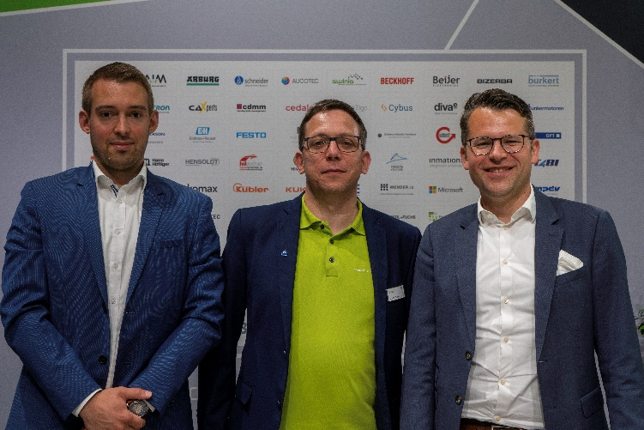
When manually transferring data from one IT system to another, the use of a standard that is not comprehensive and interoperable can cause friction. The Open Industry 4.0 Alliance wants to prevent this by adapting the ECLASS, providing a unified cross-industry standard. Currently, ECLASS includes about 45,000 product classes and over 19,000 unique characteristics that can be categorized into four levels. This allows each product and service to be represented by an eight digit code. Features, such as supplier name, type or manufacturer designation, can be contained in additional, machine-readable identifiers.
“Our cooperation with the Open Industry 4.0 Alliance supports companies in the field to represent their product descriptions digitally and implement Industry 4.0 initiatives,” says Thorsten Kroke, Managing Director at ECLASS e.V. “ECLASS is the semantic standard for digital product illustrations and services of the European industry. Companies can – in cooperation with partners like the Open Industry 4.0 Alliance – use our standard as an important building block in creating a complete representation of a digitaltwin.”
“The Open Industry 4.0 Alliance relies on the integration of existing market standards for its members and end customers. ECLASS is particularly well suited to exemplify such integrations,” said Ricardo Dunkel, Technical Director at Open Industry 4.0 Alliance. “We are taking this standard and integrating it into our reference architecture and implementation approach, allowing the management shell to bring the digital twin to life – and subsequently find its way into the production floors of our members and end users.”
A video about the cooperation between ECLASS and the Open Industry Alliance is available here: https://youtu.be/tYwsAn8dPZk
Photo material:
Ricardo Dunkel, Technical Director at Open Industry 4.0 Alliance, wants to bring Digital Twins to life with ECLASS
© Open Industry 4.0 Alliance

About ECLASS e.V.
ECLASS e.V. was founded on November 14, 2000 by 12 major companies of the German industry. By 2020, the association had around 150 members worldwide from business, associations and public institutions. Fundamental to electronic procurement of services - just as with material products - is a standard for the exchange of information between suppliers and customers. ECLASS e.V. is a non-profit organization that defines, develops and disseminates the classification and master data standard of the same name internationally across all industries.
More information here: https://eclass.eu/
About the Open Industry 4.0 Alliance:
The Open Industry 4.0 Alliance acts as a partnership association of leading industrial companies that pragmatically participate in the implementation of cross-vendor Industrie 4.0 solutions and services for manufacturing plants and automated warehouses. In industry and technology working groups, industry experts develop use cases and implement them technically based on the OI4 reference architecture. These solutions, along with implementation guides, are shared in the community and made available outside the Alliance. The Alliance was launched in April 2019. The seat of the association is Reinach, Switzerland.
More information here: https://openindustry4.com/
Press contact:
Open Industry 4.0 Alliance
Felicitas Schurig, Berkeley Kommunikation
Tel. +49 89 747 262 41
E-Mail: oia_de@berkeleypr.com

